PCR Booster Club

What is it?
The PCR Booster Club is being established to benefit the Team. The funds raised will be utilized to impact the mission of empowering youth through rowing. This means that all proceeds will go directly toward benefitting the team.

Why Join?
PCR is a FREE non-profit program open to Philadelphia Public High School Students. We operate on a budget that is based on the donations of a few very generous individuals and organizations. In order to continue to grow and meet the needs of these young student-athletes, we need additional support. Become a part of our PCR community.

How to Join?
Anyone who wants to support PCR can join. The minimum cost is $20 per person. For your membership fee, you will receive a Car Magnet that you can proudly display and show your support for PCR. To join, download and complete this application and email it to terry@philadelphiacityrowing.org and then use Pay Pal or you can print the form and send a check to PCR Boosters, 450 Plymouth Road, Ste 305, Plymouth Meeting PA 19462.

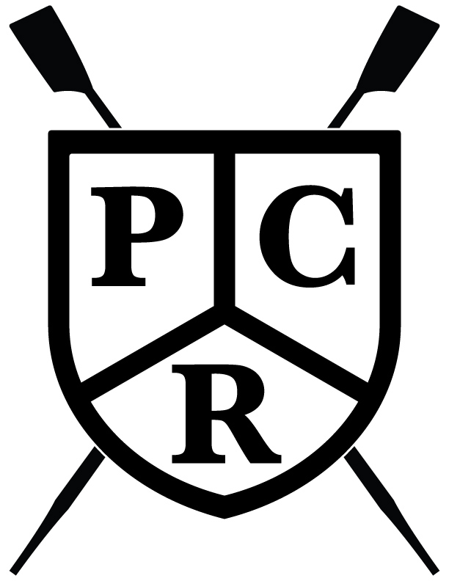
Booster Club 2017

NAME

ADDRESS

EMAIL

Parent/Guardian Relative of Rower PCR Supporter
Please circle

PCR BOOSTER $20 Additional Contribution Amount

Email to : terry@philadelphiacityrowing.org

Mail to: PCR Boosters, 450 Plymouth Road, Ste 305 Plymouth Meeting PA 19462.

